|  |
| --- |
| My certification course documentation on |
| Introduction To Wireless Power Electronics |
| A Udemy course documentation |

|  |
| --- |
| By - Vishwesh V Bhat |

We have had wireless power powering electronic devices in the house for nearly 100 years now.

A special type of circuit called a crystal radio is able to receive transmissions from high powered AM radio transmitters and convert the received radio waves into music. These crystal radio receivers require no batteries and they're powered entirely by the energy of the radio waves moving through the air. These crystal radios are cheap and easy to build. In fact for decades now there have been kits marketed to children where a seven year old can put one together.

Although wireless power generation is that easy we do not see wireless much around us in our daily lives. This is because of the comparatively lesser amount of power produced by wireless*.* In reality a crystal radio receives a power in the order of *Nano watts.* Nano watts is just adequate to produce faintly audible music and is nowhere near power for devices like laptops and phones.

Let us consider the example of charging a phone. A normal phone charger delivers up to 5 volts and 0.5 amps that is 2.5 watts. And for devices like laptops, the typical laptop chargers deliver 40 – 100 watts

For this course we will limit our expectations on wireless power generation to 2.5 watts which in our consideration is enough for a phone to power up. And this is also considered to be commercially viable.

We will walk through the various methods of wireless power that have been attempted throughout history.

* **Tesla coils**:

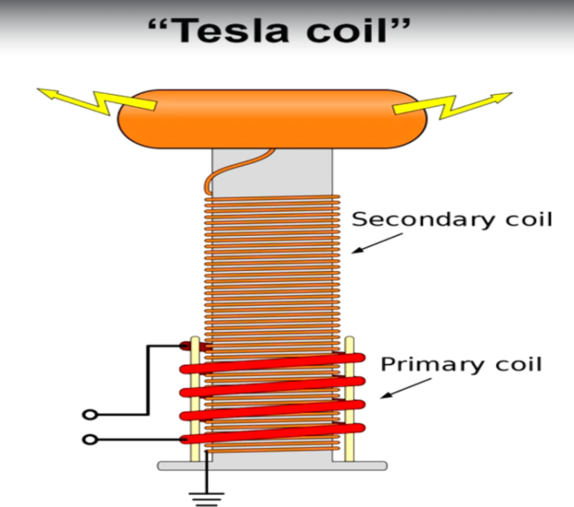A Tesla coil is an electrical resonant transformer circuit designed by inventor Nikola Tesla in 1891. It is used to produce high-voltage, low-current, high frequency alternating-current electricity. Tesla experimented with a number of different configurations consisting of two, or sometimes three, coupled resonant electric circuits. Tesla used these circuits to conduct innovative experiments in electrical lighting, phosphorescence, X-ray generation, high frequency alternating current phenomena, electrotherapy, and the transmission of electrical energy without wires. Tesla coil circuits were used commercially in spark gap radio transmitters for wireless telegraphy until the 1920s, and in medical equipment such as electrotherapy and violet ray devices. Today, their main usage is for entertainment and educational displays, although small coils are still used as leak detectors for high vacuum systems. It takes AC voltage as input, it consists of a special circuitry called the “tank circuitry”, lets not go into detail. This device could to some extent transmit power through the air.

**Disadvantages:** A. Tesla coils are large. Which means both the transmitting coil and receiving coil would be equally large and would make the circuitry very large.

1. Tesla coils produce lethal amount current in the air and might pose risk to humans.
2. In reality Tesla coils produce massive amounts of electromagnetic interference, which means if it was used in homes, the radio, WIFI and telecommunications would quickly drowned up by radio noise.
3. Tesla coil would draw power even if there were no receiving devices, etc…

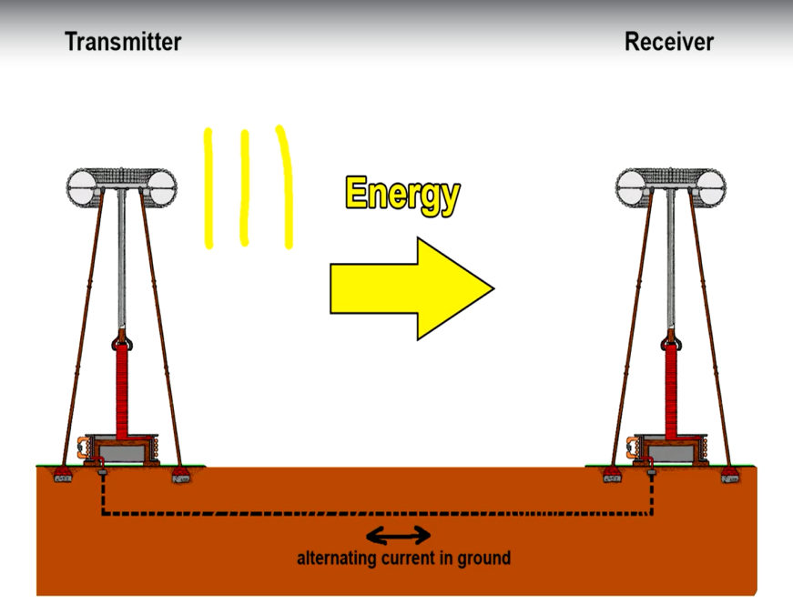Here we see that the Tesla transmitter coil and the Tesla receiver are not entirely what we mean by wireless. There is always high amplitude, high frequency AC current through the ground between the two. Charge carriers or electrons oscillate back and forth at the same frequency as the transmitter.

This creates a return path for the current. This can lead to radio interference, safety and environmental concern if it was implemented in an urban environment. It would be more accurate to describe this as “single conductor power transfer system”. But this is when the concept or idea of wireless power transmission was born and led to the modern wireless power transmission. This was indeed a milestone.

For more clarity refer link - <https://www.spigellab.com/2016/05/27/basic-teslas-experiments-part-1-100w-wireless-transmission-without-ground-connection/>

* 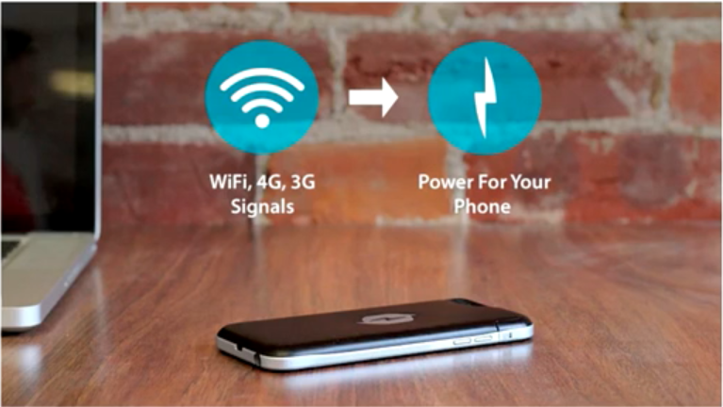**Other technologies that were innovative but not feasible** :

1. A startup called Nicola labs came up with an idea ,that would allow phone charging just with WIFI. So the idea was that a WIFI receiving antenna would harvest radio frequency that could be received by a power conversion circuitry in the phone where in nearly 5V would be produced to charge the phone. But this failed as total wattage of just 16.8mW could be generated which is not enough for phone charging. And added to that the Tx was right next to the Rx to reduce losses and other positive factors.

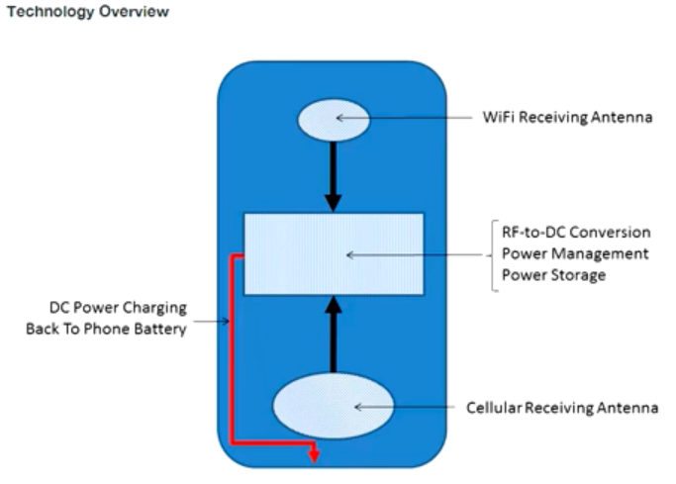

1. Another idea was the “RCA Airnergy”.

This again failed. The product was like a router, it propagated radio waves in all directions around it.

As radio waves propagate further away from the transmitting point lesser power can be tapped. That is, closer we go to the transmitting point more power we can tap.

This follows the inverse square law. As we go further away from the center of the sphere

We will be subjected to lesser power. If we doubled the distance away from the center the power that we could tap would become 1/4th or 4 times lesser.

* **Friis Transmission Calculator: link -** <https://www.pasternack.com/t-calculator-friis.aspx>

The above link takes us to an online calculator that can calculate the “*Received Power”* for user given input values for the below parameters in the **equation**:

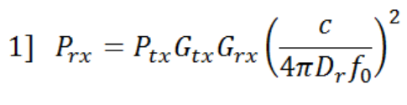

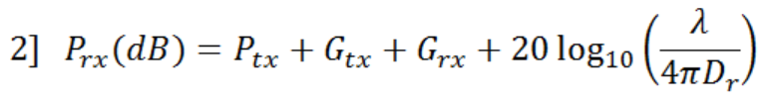

Where, c – speed of light, P – power and G – gain. In the denominator we have the formula for the surface area of a sphere (As we have discussed previously).

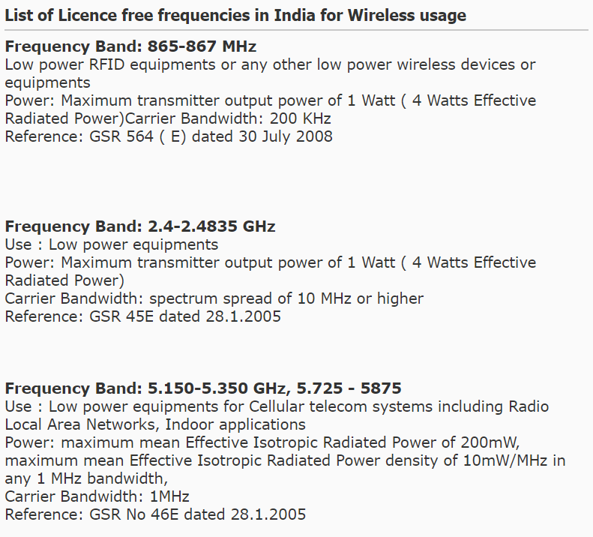**NOTE:** It is a thumb rule from most governments that the maximum power output of any radio transmitter without license must be lesser than or equal to **1 watt**.

Here is a snap from an Indian website.

So by default if we consider the transmitter power to be 1 watt, we observe that we get a very small value of received power.

We have until now considered *isotropic* radio wave transmitter. That is, the radio waves propagate in all directions. And we saw what the drawbacks were. The inverse square law, very minimum amount of received power, etc…

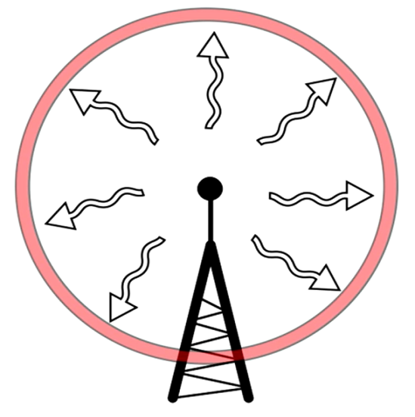 - Isotropic radio wave transmission.

But now we will be considering a *directional antenna* to solve this problem of the wave propagating in all directions, spreading out and being unable to serve for the power requirement.

**Directional Antenna:**

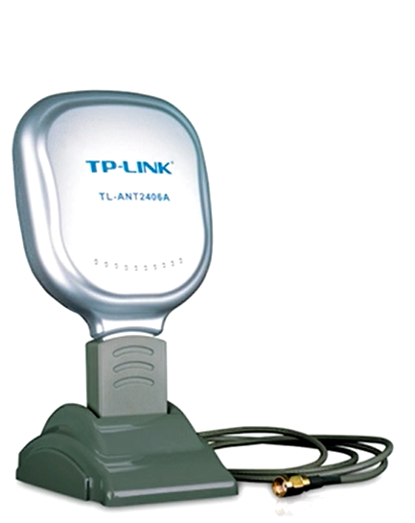 - This is usually how it looks like. And can be easily bought online.

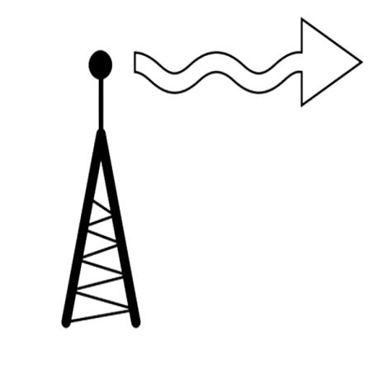 - This is what they do, make the radio wave propagate out in a specific direction.

* **What is the GAIN (dB) of an antenna**:

Gain of an antenna is a way of describing how much a directional antenna increases the strength of a signal. Gain is measured in dBi which is a logarithmic scale.

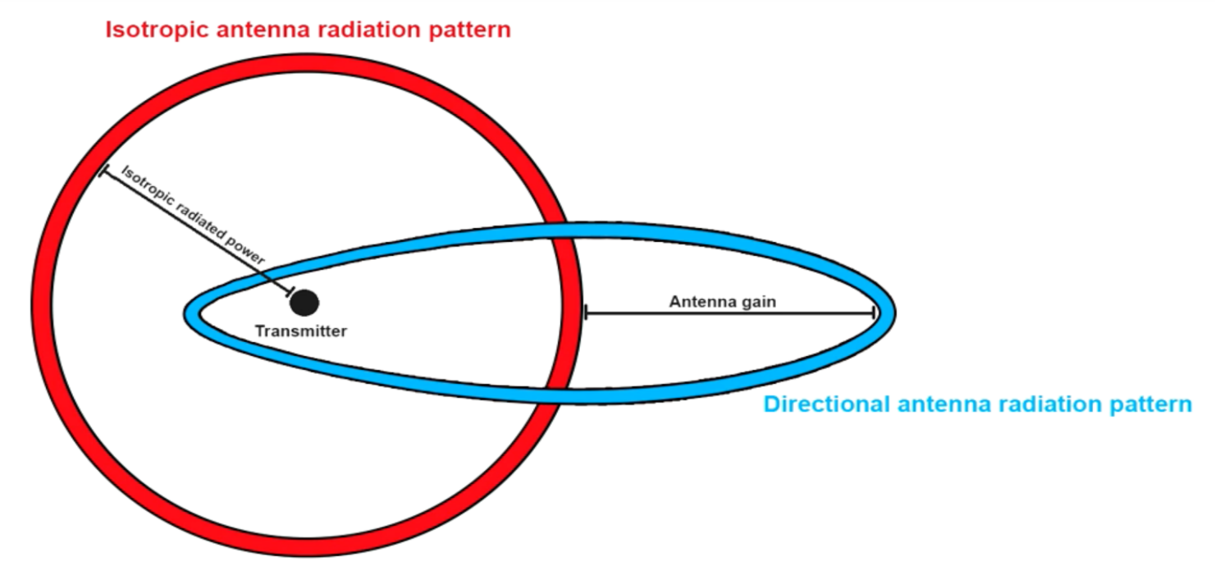

Directional antennas transmit and receive signals in a particular direction. And for now we could just gain the ability of our directional antenna to do this.

In the United States the FCC (Federal communication commission) decides the maximum power output of a radio transmitter. In India we have the TRAI (Telecom Regulatory Authority of India) And WPC (Wireless planning and coordination wing). The FCC limits the ability of the American locals to use high gain antennas on their transmitters to 6 dBi and it is same in India too (Image below).

(Below is the image reference taken from TRAI website - <https://www.trai.gov.in/sites/default/files/201506090333529087238siddharth.pdf>)

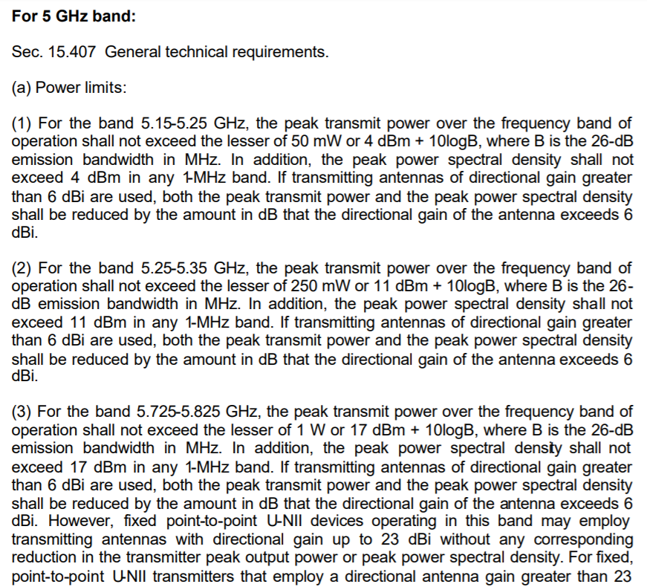

We can see in the above reference, that for every different frequency band mentioned above the directional gain of the antenna is to be fixed at 6 dBi.

And it is also important to note that there is no such gain limit for the receiving antenna. So the highest gain we could have for our receiving antenna is 24 dBi without using a huge satellite dish.

Here is an image of a 2.4 Ghz,24 dBi die cast antenna:

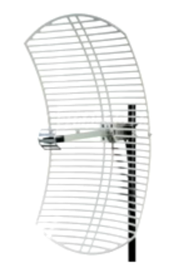(Description and specs can be found online)

Let’s say we use this antenna on the receiver end to increase our received power.

Calculating for these values on the Friis calculator:

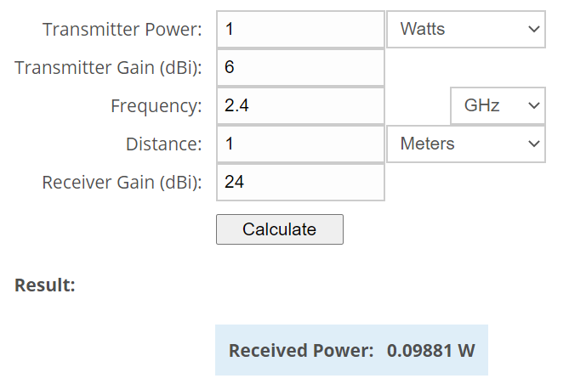 The received power turns out to just nearly 0.1 Watts.

Even after getting the high gain receiver, we are not able to get our requirement of 2.5 Watt that is required to power up a cell phone.

And the directional antennas are usually large when compared to the tiny antennas found on PCBs. Why would consumers go for a large antennas to charge their phone when wired charging happens much easier.

And using such big antennas will restrict mobility. The receiving antenna we have considered above has a beam width of 10 degrees. So there are high chances that if the consumer was moving around the room with his phone, the connection would be broken and the charging would stop.

Now that we have come this far through the course, we have seen that it is possible to transmit and receive power wirelessly using radio waves. But, the power received safely and legally is very tiny. So powering up a phone using RF waves is not practically feasible or we could just say it is not possible. Pros and cons of RF wireless power:

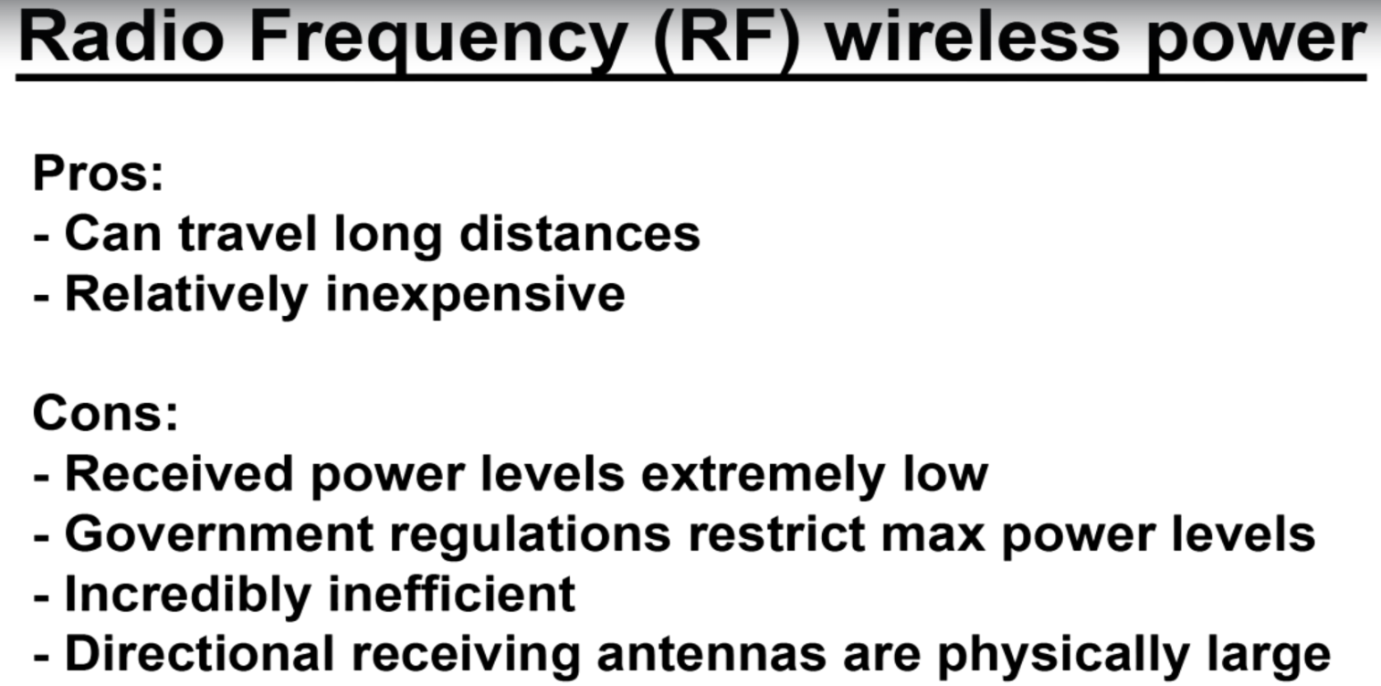

**So let’s move on to the next innovation and see if it works.** We now have two innovations to consider under the concept of charging phones wirelessly:

1. With nothing more than **tiny vibration(Piezoelectric):**

**The idea is that we could use piezoelectric effect to generate electricity to charge batteries. Like charging the phone while we type with the pressure we apply on the screen. Pressure causes polarization in the piezoelectric material used.**

* **What is a piezoelectric device?**

Basically, a piezoelectric material produces a change in potential across it when it is squeezed. Also, if you apply a potential difference across it you can get it to expand a little bit. When pressure is applied to the material, the material becomes polarized. This polarization creates in internal electric field and thus a change in electric potential across the two sides. Take references from - <https://www.wired.com/2011/07/can-you-charge-your-phone-by-typing/>

1. With nothing more than **ambient noise:**

**The idea here is to be able to charge phone with just sound. Like charging the phone while we take calls. Let us understand more:**

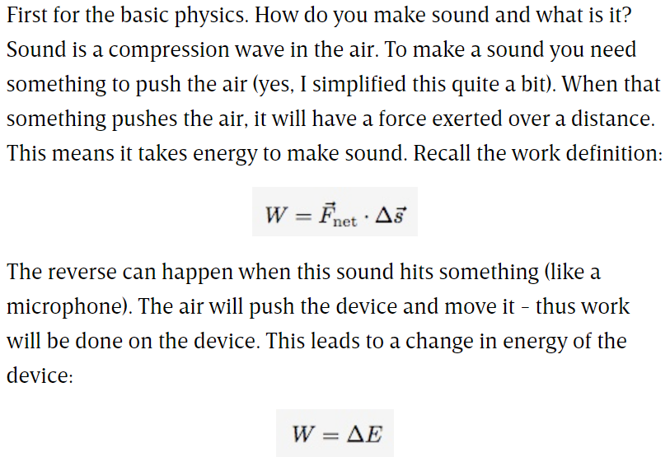

So, it takes energy to make sound and you can get energy from sound. So this much understanding is enough about the innovation because this again has failed to cater to efficient wireless charging. Take references from - <https://www.wired.com/2008/12/charging-a-cell-phone-with-sound-possible/>

For both these innovations we have seen above. There are factors that the outputs depend on. In the first case it is the pressure. Is the pressure we apply on the screen enough to charge it?

And in the second case it is the intensity of sound we create while we speak on phone. Is this intensity of sound that we create enough to charge the phone?

And if we do little research about the above ideas on the internet, we find that only the voltages that we can generate using the above methods are mentioned everywhere. It is not the voltage that charges our phones. It is the power. Power and voltage are not the same. There is always a little amount of current that is required with the produced voltage to cater to our power requirement.

**To make it more understandable**: We know that the voltage we get from a static shock can be of thousands of volts. But yet we cannot charge phones with static electricity because there is not enough current to cause the power.

**To conclude: When we cut through all the hype, both the above ideas, that the piezoelectric chargers and the ambient noise chargers simply do not have enough energy to support viable phone charging.**

**Why we are looking into failed innovations is that, we still find these on the market and we need to understand their limitations so that we will not be victims to scams.**

1. With **conductive charging pads (Conductive wireless chargers)**:

How this works is, we have a grid of electrically conductive squares. And we insert a special sticker into the charging port of our phones, adding two electrical contacts to the back of phones. (See images below)

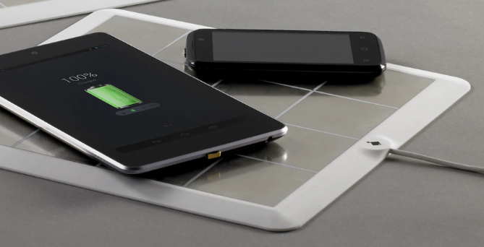This is how the charging looks over a conductive pad.

And the next image shows the conductive strip on the back of phones. This method is known for delivering fast charging.

Take references - <https://www.kickstarter.com/projects/700146891/energysquare-always-stay-charged?ref=most_funded>

Let’s give it another thought. Is this truly the wireless we want? Though we do not have the conventional wires (wires of the USB cable), we still have conducting strips and pads. Below are the pros and cons:

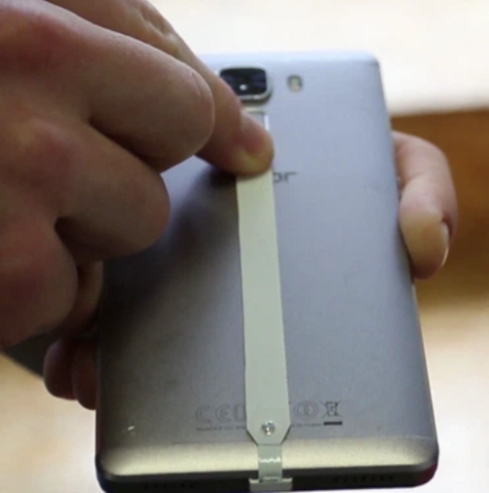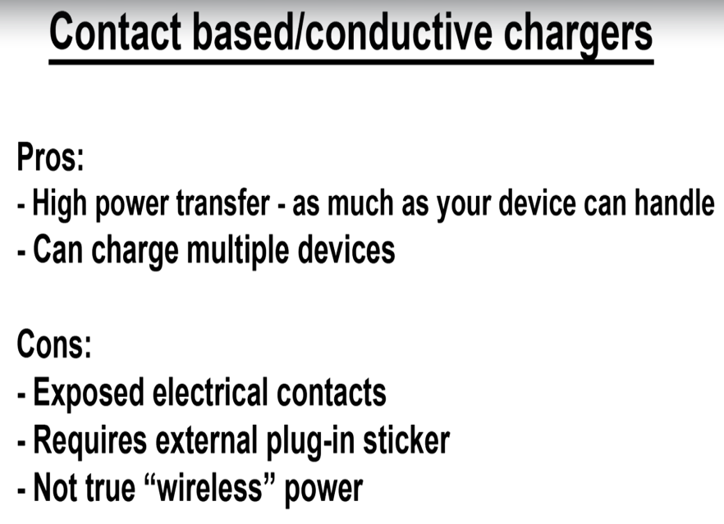

* **Now let’s move on to the methods that work and which are widely being used in the industry right now:**

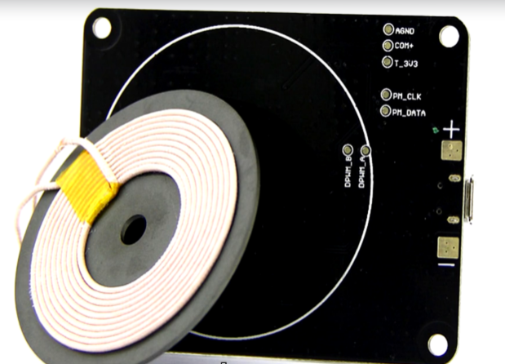It is the inductive methods that work were well for wireless charging. The wireless charging schemes that we see in the modern Samsung phones and apple watches uses a system called the “Inductive resonant power transfer”.

Here’s the game plan:

Let’s start out with a review of the **basics of electromagnetic induction and inductive coupling**. Then we're going to talk about **inverter circuits** and build a really simple wireless power transfer system. Then we're going to talk about **resonance** and why it makes all the difference in wireless power. Next we're going to upgrade our wireless power system and **observe the gains in range and efficiency** then we're going to talk about the shortcomings in our system and how modern solutions such as the standard and address them.

* 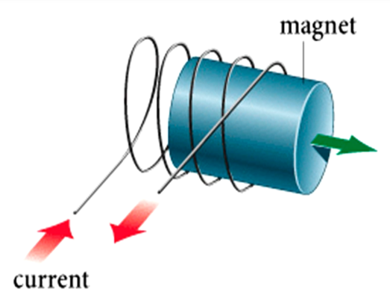**Basics of electromagnetic induction:**
* Whenever you have a magnetic field moving through a coil of wire you get an electric current.(Image 1)
* And whenever you have a electric current flowing through a coil, there is always a magnetic field around the it.(Image 2)

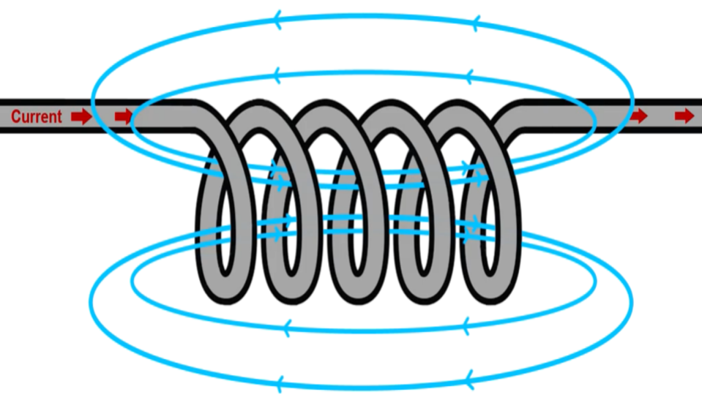

There are various methods of verifying this phenomenon.

We can take ample references from the internet. Thus, we will not dive deep into the basics.

Now let’s consider a **transformer**.

* 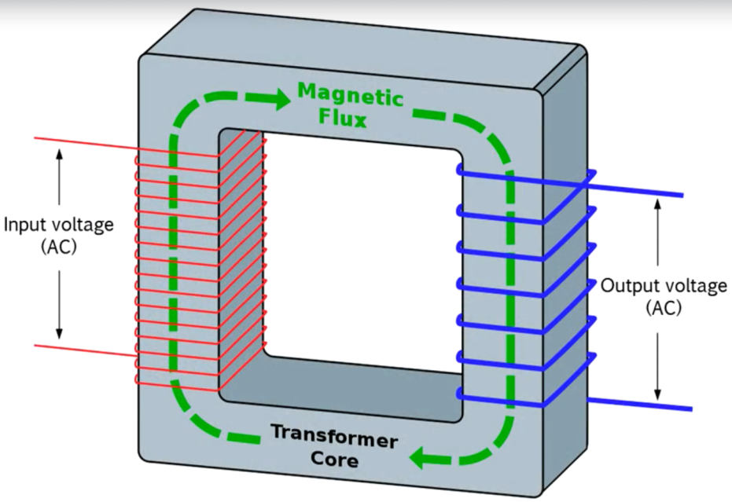**Transformer** is a device that works on the principle of mutual **Inductance.**
* A transformer takes in electricity

Turns it into magnetic field and again turns it back to electricity.

If you push and pull alternating current through the input of a transformer it creates an expanding and collapsing magnetic field within the Transformers core.

* Now when you put this alternating magnetic field in the presence of another coil the moving magnetic flux will induce electrical current into this secondary coil.
* So you'll get another AC voltage on the output side of the transformers.
* This only works with alternating current because of the rule we saw above where current only gets induced when magnetic flux is moving through the core of the transformer which is made of a metal that enhances the magnetic field increasing its strength for a given current flowing through the input thereby increasing its efficiency in real life.
* 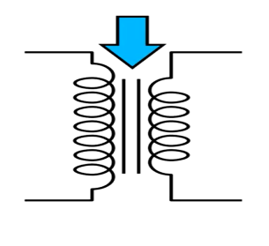These transformers of course are usually made out of a ferromagnetic material like Iron. And they tend to be really big and heavy.
* Now let us see the circuit symbol of transformer:

The two parallel lines that we see in between the windings symbolise the metallic core of the transformer.

Inductive wireless power transfer is basically the same thing as without an iron core.

* You essentially create an air core transformer and it works the same way as a regular transformer.
* You **push and pull current through the input** or the primary side of the transformer.
* This **causes a changing magnetic field to be created in the air gap**.
* And then this magnetic field moving through the secondary coil **induces alternating current on the output**.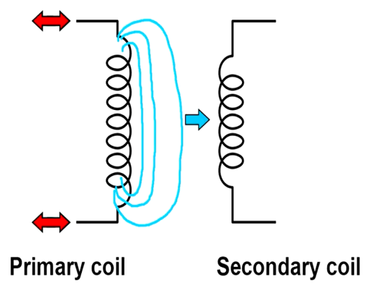
* **Resonance:**

Resonance occurs when the frequency of a vibrating force exactly matches a natural (resonant) frequency of the object to which the force is applied.

To simplify that definition, we could say resonance is a condition wherein a force that need not be maximum force that is applied on a body causes a considerable effect on the body onto which the force is applied.

References –

1. <https://www.youtube.com/watch?v=UIdgwL_EAZo>
2. <https://www.youtube.com/watch?v=3mclp9QmCGs>

Some very good examples of resonance are:

1. Collapse of Tacoma Bridge.
2. Opera singers breaking wine glasses by singing at a particular frequency (Resonant frequency).

* **What is resonant frequency?**

**Resonance frequencies are the natural frequencies at which it is easiest to get an object to vibrate.** While setting up vibrations at other frequencies is possible, they require much more energy and constant input to maintain than a resonance frequency. Most objects have several resonance frequencies, and this property must be taken into account because of their positive, as with musical instruments, or negative, as with bridges, effects.

* **To see why is resonance in the scope of our discussion regarding wireless power transmission:**

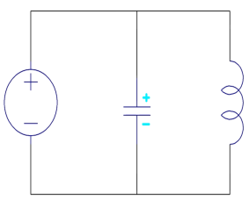Consider a circuit as shown:

So we have a battery, a capacitor and an inductor. The battery charges the capacitor to a certain voltage. So energy is stored in the capacitor in the form of an electric field.

Now let us remove the battery:

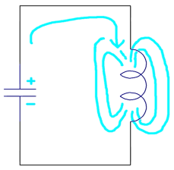The voltage from the capacitor moves across the inductor and induces a magnetic field through the inductor. This continues till all the capacitor voltage is drained.

As whenever we have a magnetic field around any coil, we always have a current in that coil.

A current flows from the inductor to the capacitor. And charges the capacitor again until the magnetic field across the inductor weakens.

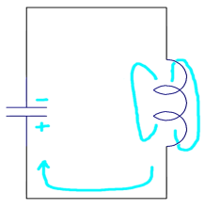And this continues until the magnitude of the voltage and the current slowly reduce due to factors like resistance in the wires and coils.

Thus to keep the process going on we would need to supply the system with a continuous AC supply.

Whenever we have to supply AC current, choosing the frequency plays a very important role. We will have to generate such a frequency that will require minimum energy and that can cause maximum surge in the voltage and current of the system this kind of frequency is known as the resonant frequency.

Now going back to our air core transformer about which we had discussed earlier. The air core transformer requires AC supply and is best operated at resonant frequency. As the air core transformer very relevant to wireless power transmission, resonance becomes relevant too.

We also saw how a **LC resonance circuit** works (The circuit with one Capacitor and one Inductor).

References –

1. Series LC resonance circuit – <http://www.falstad.com/circuit/e-res-series.html>
2. Parallel LC resonance circuit – <http://www.falstad.com/circuit/e-res-par.html>
3. LC Tuned Circuit Resonant Frequency Calculator - <http://www.ham-radio.com/lc.html>

Let’s attempt some questions: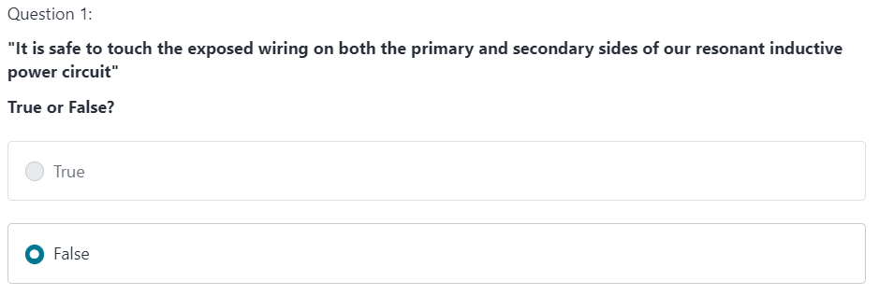



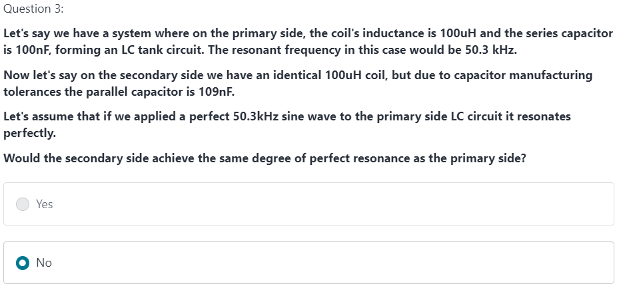

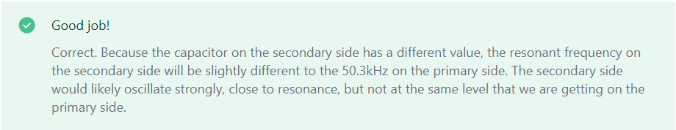

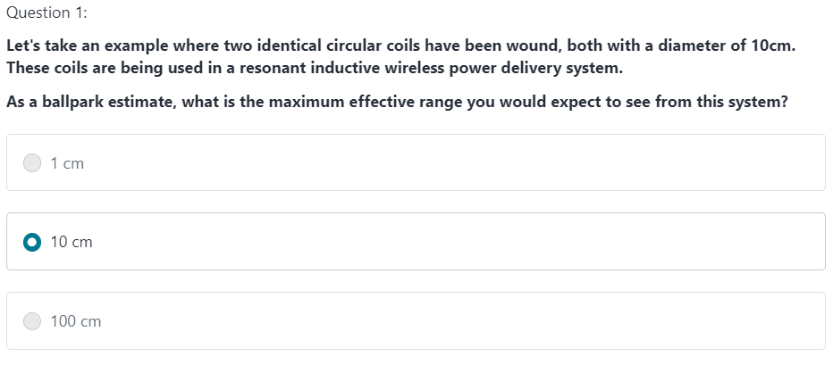



Thus, **we can increase the effective range by increasing the diameter of the coil**. However we have to note that **as we increase the diameter of the coil, the effective power that is delivered goes on decreasing**.

Now that we know how inductive power transfer happens and how one can be setup. The question is:

**Is this enough to setup a wireless charging system for a cell phone, or do we have to consider more aspects?**

The answer: **We have to consider more aspects that we don’t see with our bare eyes but such aspects will considerably effect the functioning of the system. One such aspect is heating of coil.**

* 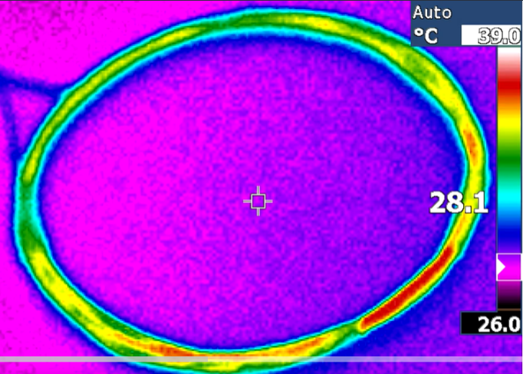To keep the coil sizes small, wireless power transfer systems often operate at **several 100KHz** and sometimes even MHz range.
* Once you start getting into frequencies of several hundred kilohertz and above copper wire no longer behaves like a simple wire with resistance.
* What happens is that **the alternating current in the wire tends to flow only near the outer surface of the wire effectively reducing the cross sectional area of the wire effectively increasing its impedance**.
* Let’s say for instance at 100 kilo Hertz the amount of **current that can flow through the centre of the wire decreases current flows more around the outer surface of the wire than the centre informally**.
* It appears like **current is only flowing around the outer skin of the wire**.
* So we call this effect the **skin effect** at 100 kilohertz the skin depth is approximately point 2mm. Think about that for a second if you have a 1mm diameter wire and current is mainly flowing through a skin. That's point two mm deep. Most of the copper in the centre of the wire isn't effectively being used.

Reference - <http://circuitcalculator.com/wordpress/2007/06/18/skin-effect-calculator/>

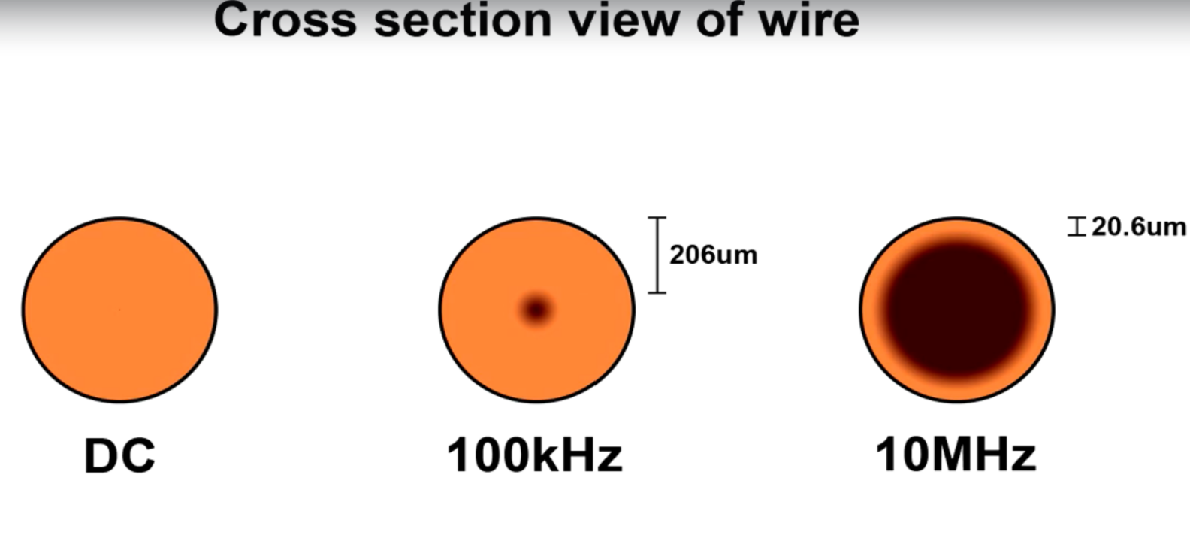

This is to show what skin effect is, as we go on increasing the frequency of the input, the current flow starts getting limited to particular skin depths of the wire. (See image above)

* In commercial wireless power systems that operate with a minimum frequency of several hundred kilohertz the skin effect leads to undesirable additional resistance in the coils which increases heat lowers efficiency and also limits the degree to which the circuit can resonate.

**SOLUTION TO THE ABOVE PROBLEM:**

* 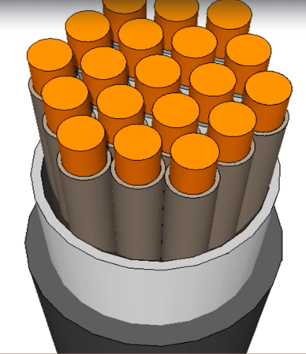 A product called Litz wire is a wire made out of dozens of insulated strands of wire in parallel since the skin effect limits the effectiveness of thick wire.
* It makes sense to just use multiple thin wires and put them in parallel. Doing this effectively recreates the fully utilized cross-sectional area of copper that you would normally have with DC.
* It's relatively expensive compared to regular stranded wire.
* So you rarely ever see it in consumer applications outside of the wireless power sphere. But if you ever see a coil that looks like this you can bet that there's high frequency AC flowing through it.
* Thus Litz wire can increase the efficiency of a wireless power transmission system.
* **Let’s take a question:**

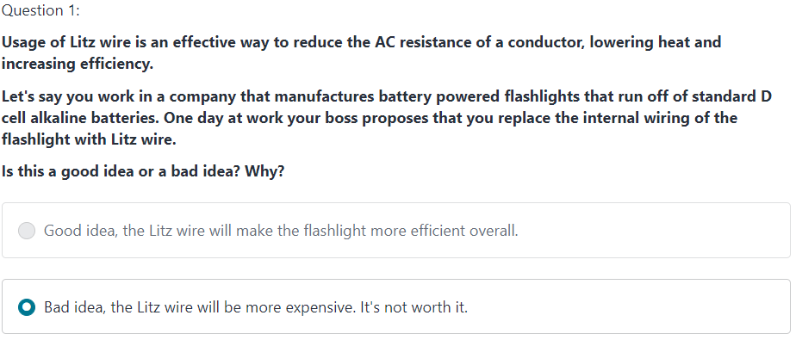



We could build a simple circuitry on bread board with transmitting and receiving coils. With the receiving coils connected to an output device that has a low voltage requirement up to 130 volts peak to peak. The circuit may look something like this:

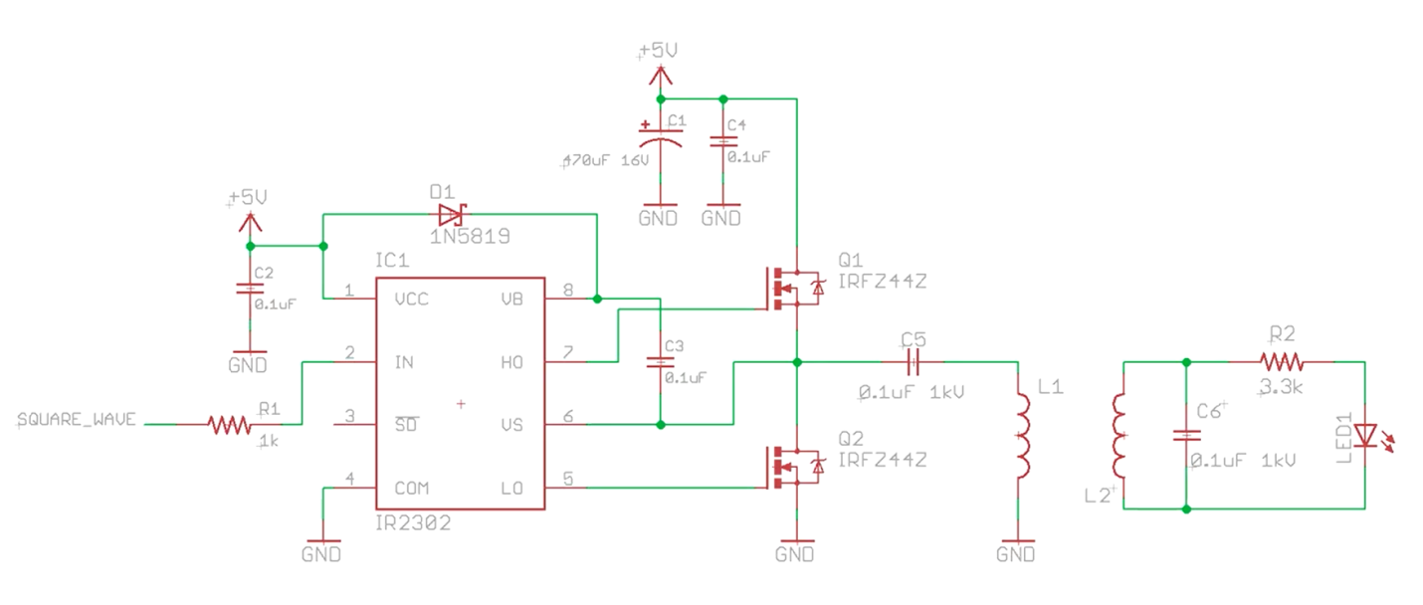

And let us agree to the fact that this does not qualify to charge a cell phone.

Look at the below image:

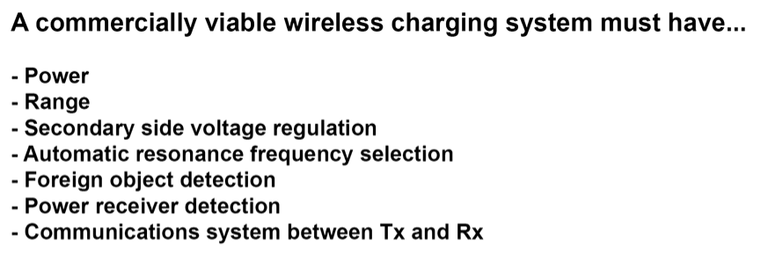

The power in our circuitry above reduced considerably for operation of small connected devices such as LED. The range is good, but range and power are mutually independent quantities in wireless power transmission so if we do changes with power, we might have to do changes to the range by planning a better diameter to our coil and the material of coil and so on…

We will have to install sensing circuitry that can automate the resonance frequency selection,

That can detect foreign object, power received, and also a feedback system that can regulate the power transfer/transmission between the transmitter and receiver.

Modern semiconductor solutions can cater to the above requirements.

In order to fulfil the above requirements in a compact and affordable way, we use semiconductors that are specifically designed for wireless power transfer. There are many organisations that are striving to build standards for wireless power transfer that is most adaptable and some of the key players in this arena are:



Qi specifications are the most used these days as Samsung decided to use this for their mobile devices.

Let us walk through this block diagram below of a typical chip that implements the Qi specification:

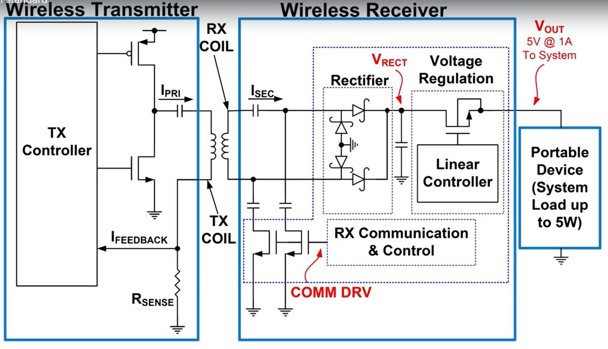

The two transistors and a capacitor portion of the above block diagram is similar to our previous circuitry.

**Rsense** is something new.

* **Rsense is used to see if the circuit is near resonance or in resonance. The LC tank circuit draws a lot of current at resonance and in contrast lesser current when not in resonance. With this information the transmit controller can adjust the switching frequency of the transistors to make the system operate out of resonance, near resonance and at the exact resonance frequency. This is a better way of what we were doing manually in the previous circuitry (with oscilloscopes).** However we can use other methods too. For example the LTC4120 which uses the power by proxy method uses the fixed transmitter frequency. Whether things resonate or note is controlled on the secondary side. The receiver chip can switch extra capacitance in and out of the receiver circuit to control the degree of resonance and thereby controlling the received power.
* On the secondary side we have a rectifier to convert AC to DC. The bridge rectifier is typically made out of Schottky diodes for maximum efficiency and high switching speeds.
* A voltage regulation circuitry is being used to always give a proper output of 5 Volts (If we are charging a phone. Say which charges at 2.5 Watts). Another efficient voltage regulation system we can see implemented in the wireless processes these days is **Buck converter switch mode power supply:**

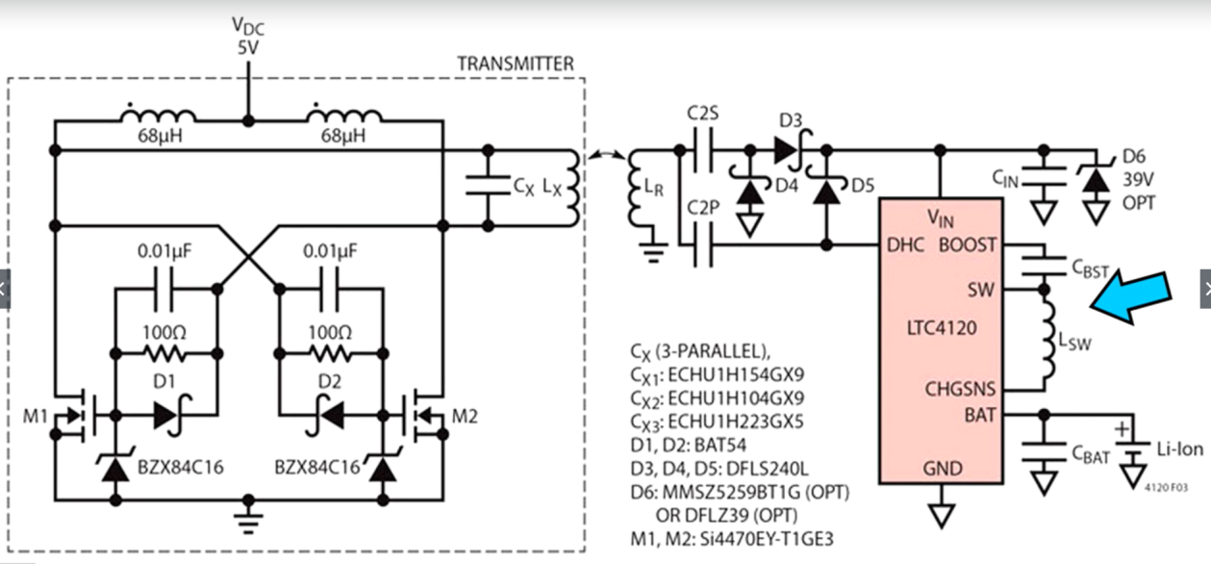

Reference for Voltage regulation circuitry –

1. <https://www.youtube.com/watch?v=CEhBN5_fO5o>
2. <https://www.youtube.com/watch?v=QR8qsygs1Kw>
3. <https://www.youtube.com/watch?v=wJU7AJgERG8>

Going back to our Qi block diagram:

* The Rx communication and control is a capacitance switching circuitry on the secondary side. It helps in communicating with the primary side by switching capacitance and bringing the frequency to resonance.

**Now let’s take a few questions:**

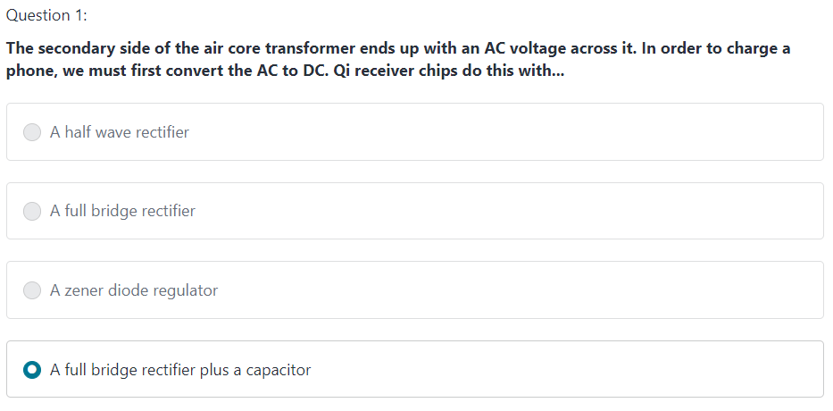



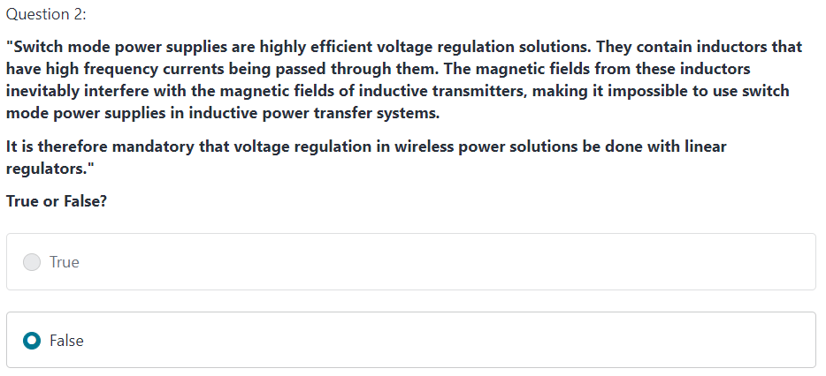



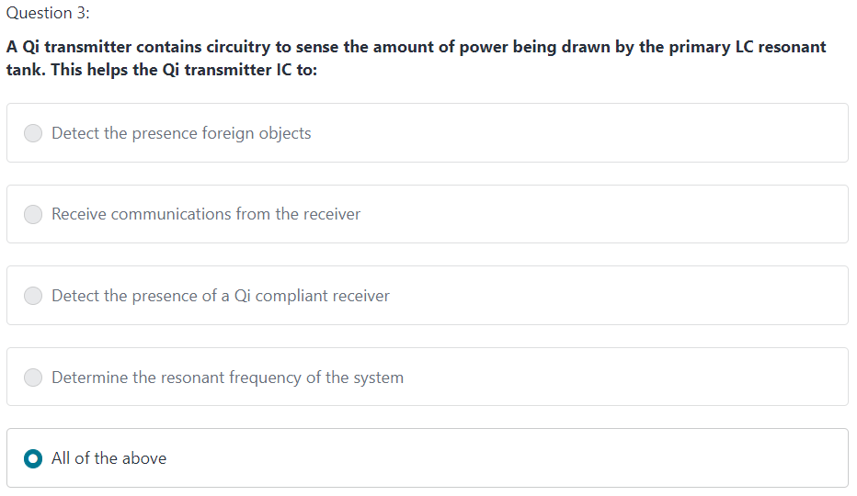



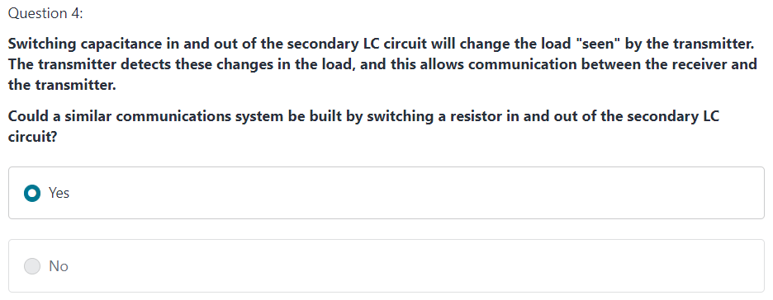



Some more references –

1. <https://www.richtek.com/en/Design%20Support/Technical%20Document/AN036>
2. [https://www.ti.com/power-management/battery-management/charger-ics/overview.html#](https://www.ti.com/power-management/battery-management/charger-ics/overview.html)
3. <https://www.analog.com/en/products/ltc4120.html>
4. <https://www.nxp.com/>
5. <https://www.richtek.com/en/Design%20Support/Technical%20Document/AN036>

Taking more questions:

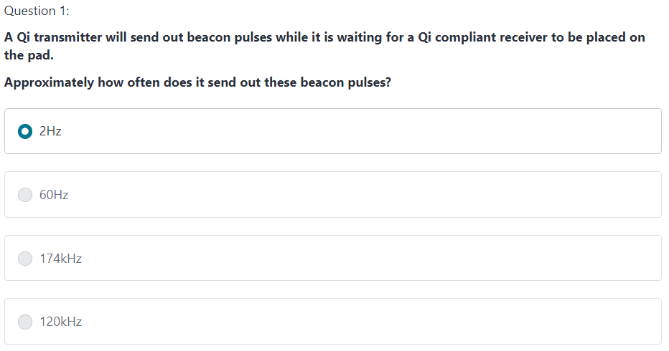



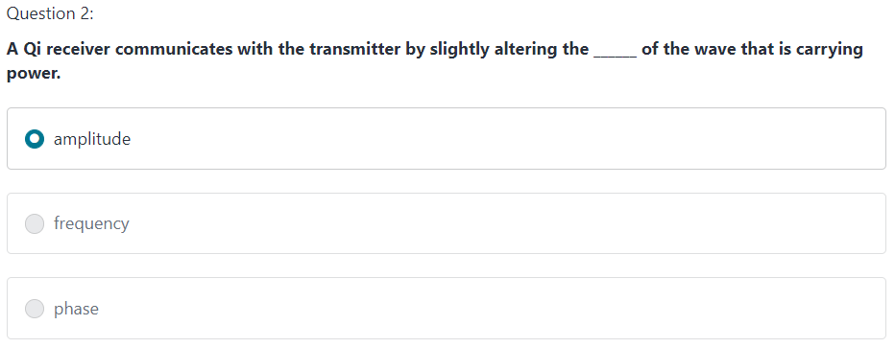



Closing off references –

1. Buy wireless tech online:
2. <https://www.adafruit.com/product/2116>
3. <https://www.adafruit.com/product/2162>
4. <https://www.adafruit.com/product/2677>
5. <https://www.digikey.com/products/en?keywords=445-9305>
6. <https://www.digikey.com/products/en?keywords=800-2975>
7. Some more links –
8. <https://witricity.com/>
9. <https://s3-us-west-1.amazonaws.com/disneyresearch/wp-content/uploads/20170215220933/Quasistatic-Cavity-Resonance-for-Ubiquitous-Wireless-Power-Transfer-Paper.pdf>

